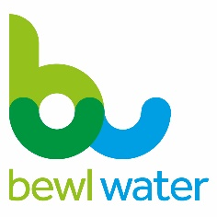
Bewl Water fishing report 10.06.19

Total number of returns | 76 |  |  | Bewl Water Fishery  Lamberhurst, Kent TN3 8JH  Tel 01892 890352  fishing@bewlwater.co.uk  www.bewlwater.co.uk
Total rainbows from returns | 230
Rod average from returns | 3.02
Average fish weight | 2lbs 7oz
 |  |  | Water level | 91%
Best fish | 5lbs 2oz |  | Water temperature | 16c

Another testing week due to the inclement weather. No two days produced similar results, and fly choice seemed to be a lottery! One wise bank regular chose a CDC fry imitation and was suitably rewarded. Others tried and often failed on all manner of patterns.
The midweek national Police competition saw some quality fish to 5lb 2oz although the sunlight saw conditions completely different to the previous practise day when the fishing was by far easier.
Saturdays Lithuanian lure competition was a considered success, despite the gale force wind and rain whilst Sunday’s ‘Loch Style’ qualifier saw a rod average of 5.75 in the sixteen strong field. Several 4lb fish were recorded.
The mid June forecast is for very cool and often wet conditions, so bring suitable wet weather gear.
***************************
Don’t forget to sign up to our loyalty scheme next time you are in the lodge – hire 8 boats get one free.
We are relying on your catch returns to provide as accurate data as possible on the fishing conditions, don’t forget that each month we will choose one return to win a free boat on a return visit, there are several ways to submit your return:
- By filling out your permit and posting it in the box by the lodge or passing it to one of the team.
- By emailing fishing@bewlwater.co.uk
- By filling out our online catch return form on www.bewlwater.co.uk/fishing.
- By giving us a call on 01892 890352.
Our new Boat House Café is open on Saturday and Sundays from 8am serving hot and cold drinks, snacks and bacon rolls. Help us keep this facility open by popping in on your next visit.

